The Millinocket Historical Society’s Paver Project Fundraiser

Help the Millinocket Historical Society complete the renovation of the second floor, basement and exterior of the new museum at 80 Central Street by purchasing your engraved paver. Purchase a paver in memory of a loved one, your children, your family or yourself. Buy a brick for your business or organization or high school class. These engraved pavers will be placed in the space between the museum’s front porch and the sidewalk.

Engraved pavers are 4” x 8” and allow for 15 characters (including spaces) per line and up to 3 lines of text. We have selected Midcoast Laser Works of Cushing, ME to do the engraving. Create a lasting memory and contribute to the preservation of Millinocket’s history.
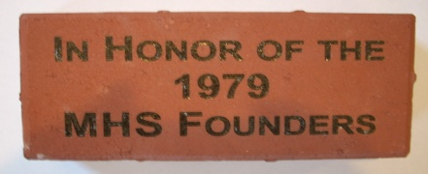 Sample paver

Please fill out the order form below, include your check or money order and return to: Millinocket Historical Society, PO Box 11, Millinocket, ME 04462 or visit the museum during open hours to sign up.

_____ 4” x 8” ENGRAVED PAVER(S) with up to 15 spaces/line and up to 3 lines of print $100.00 $_______
_____ I wish to make an additional donation to MHS Donation $_______

Total $_______

PLEASE USE THE SPACE BELOW FOR YOUR TEXT. 15 spaces each line including punctuation and spaces. Text will be centered. (Note: You do not have to use all the lines or spaces.)

Line 1: ___ ___ ___ ___ ___ ___ ___ ___ ___ ___ ___ ___ ___ ___ ___

Line 2: ___ ___ ___ ___ ___ ___ ___ ___ ___ ___ ___ ___ ___ ___ ___

Line 3: ___ ___ ___ ___ ___ ___ ___ ___ ___ ___ ___ ___ ___ ___ ___

Please provide contact information of purchaser below.

Name(s) or Business name:_________________________________________ Phone: _______________________

Mailing address: _____________________________________________________________________________
City, State, Zip: ____________________________________ Email: ____________________________________
(Note: This is an ongoing project. Purchased pavers will be installed once or twice yearly when numbers permit.)

